**LAB 5: A Calculator in Action**

**Introduction:**

This lab aims to design a calculator that uses the combination of the previous lab, which can make a display on the 7-segment display. The board will receive and take the number and add them together.

**Procedure:**

* First, we have the top module that connects the shift register we built-in lab four and the new shift register in lab 5 to generate a 12-bit command to represent the IR remote.
* Make the 4-bit adder by using the full adders and half adders function to make the 4-bit adder. The code is on the canvas. We can use the previous to make this function
* Then we need to finish the Lab5top provided in the lab by adding three lines of code. First is the shift register, four-bit adders, and 7-segment representation of the byass board
* Now we set up the IR receiver as instructed in the previous lab
* Now we run the schematic and run bitstream for loading onto the board
* Make the circuit as the previous lab and connect the board for the output
* Test with remote and add the input, and our stimulation is working right

**Pre Lab 5:**

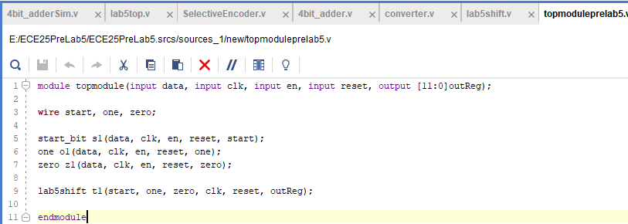

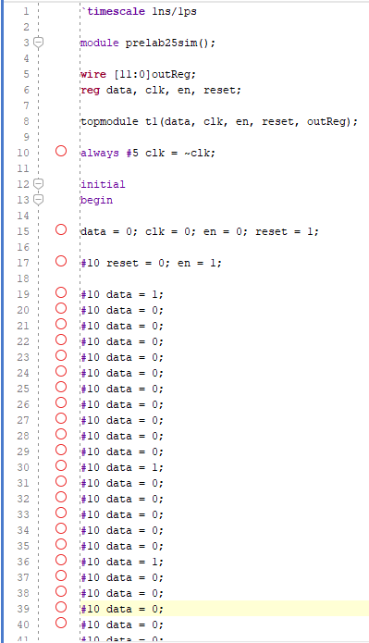

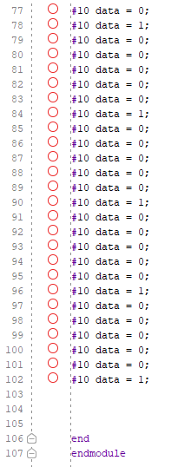

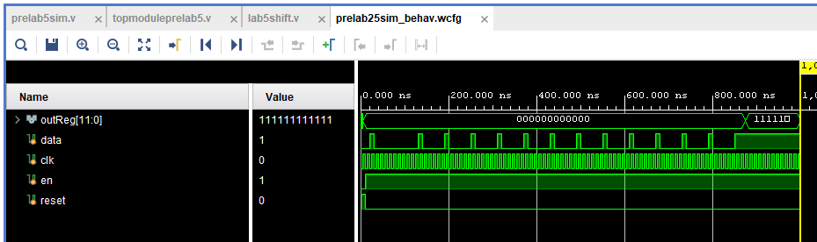

**Stimulation Testing for 12 Zero Bits Sequence:**



**Shift Register for Pre Lab 5:**

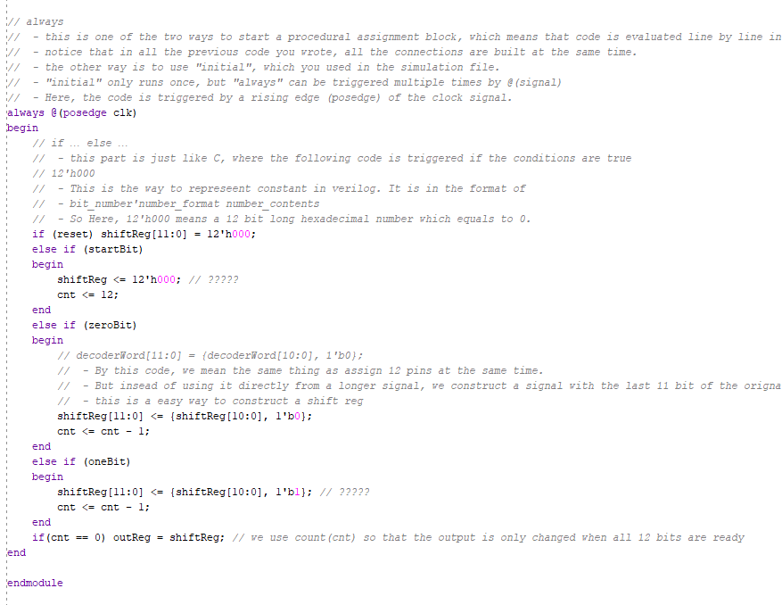

**Top Module for Lab 5:**

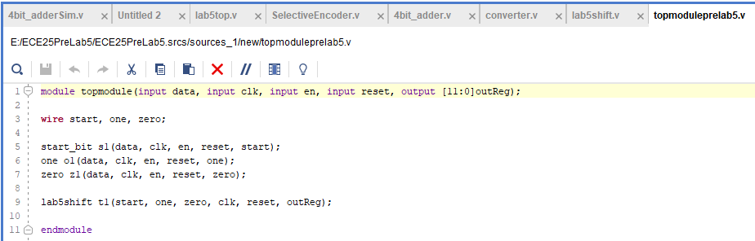

**Stimulation Code for IR Receiver:**



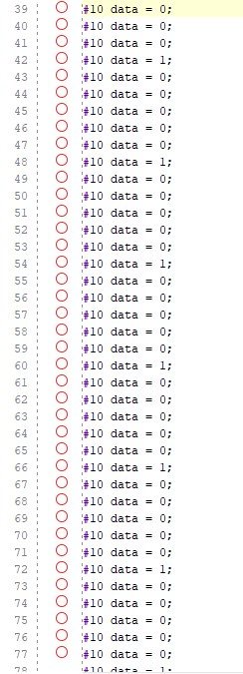



**Schematic Structure for All Module:**

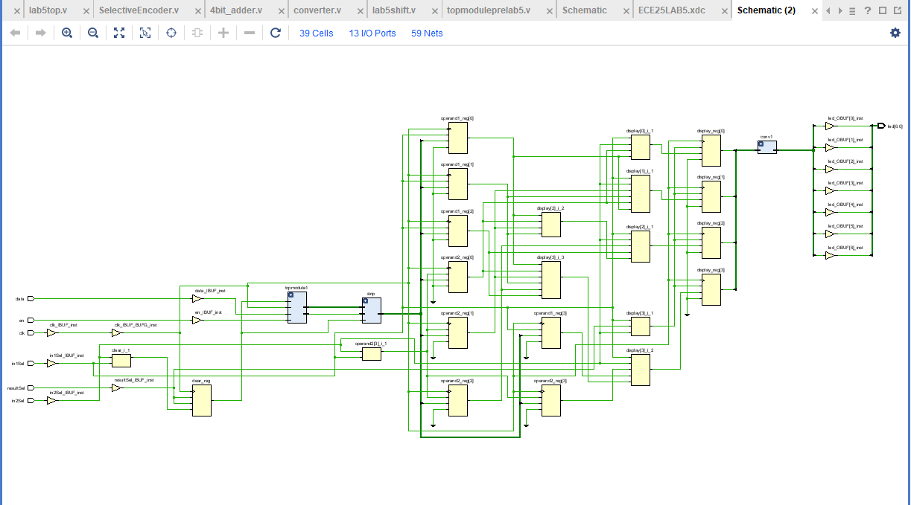

**Stimulation and Code For 4 Bit adder:**

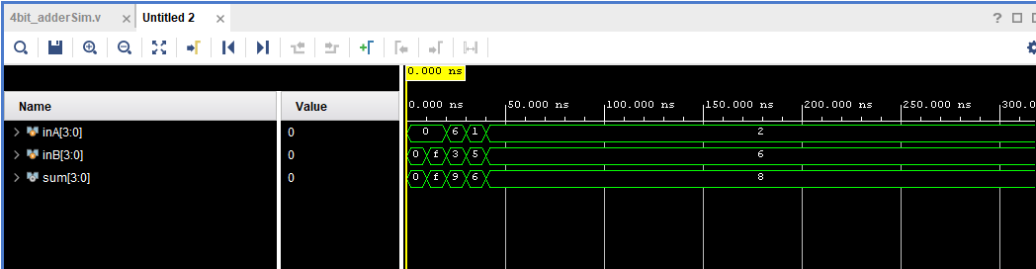

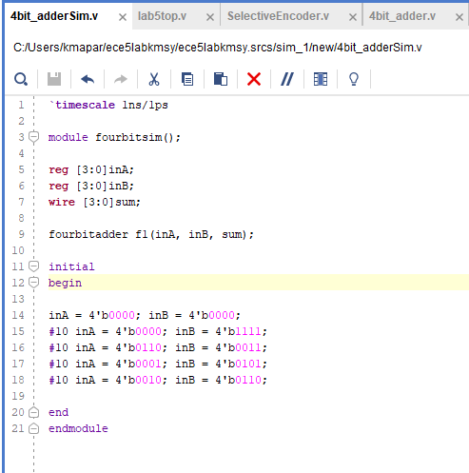

**4 Bit Adder Code:**

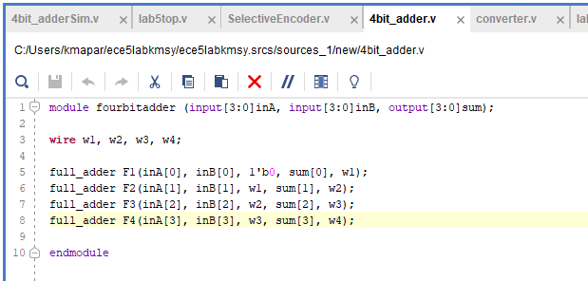

**Lab5top Fixed Code:**

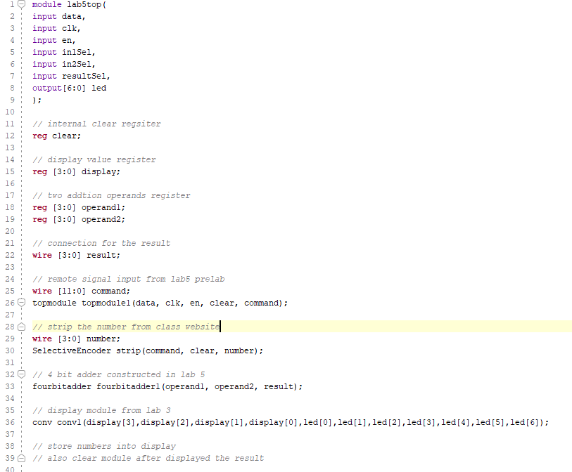

**New Shift Register from Pre Lab 5:**

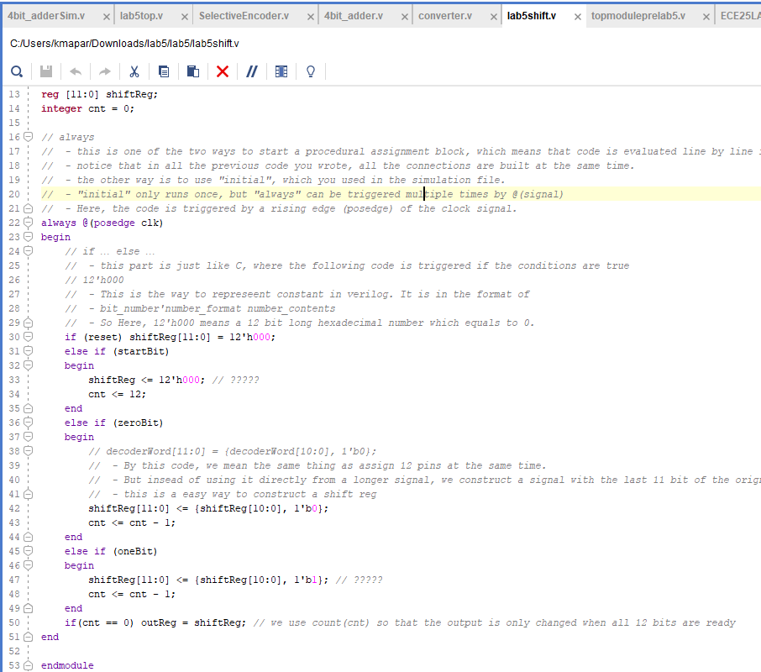

**Top Module for IR Receiver:**





**Circuit and Board:**

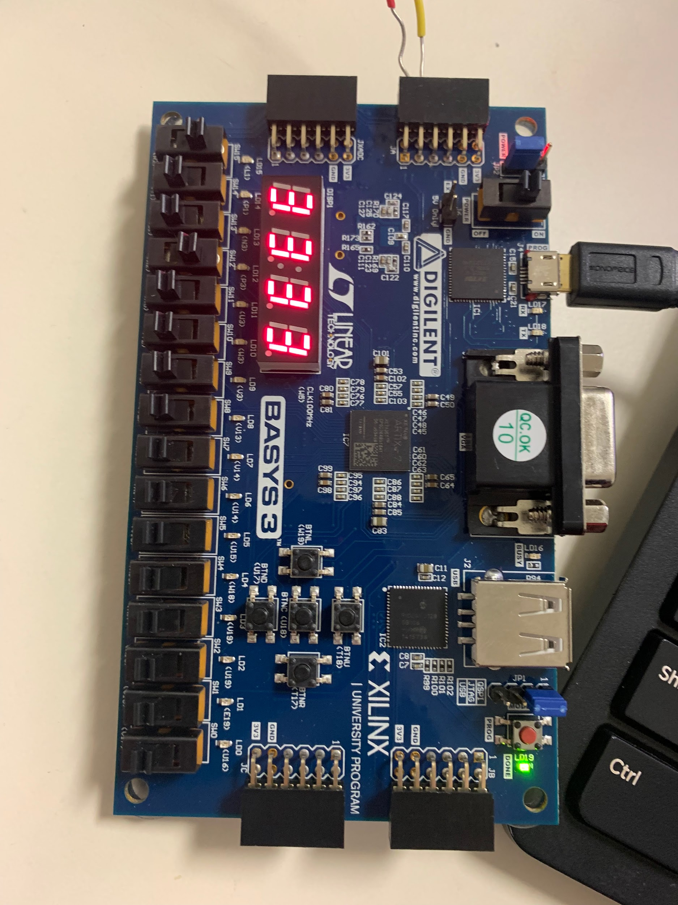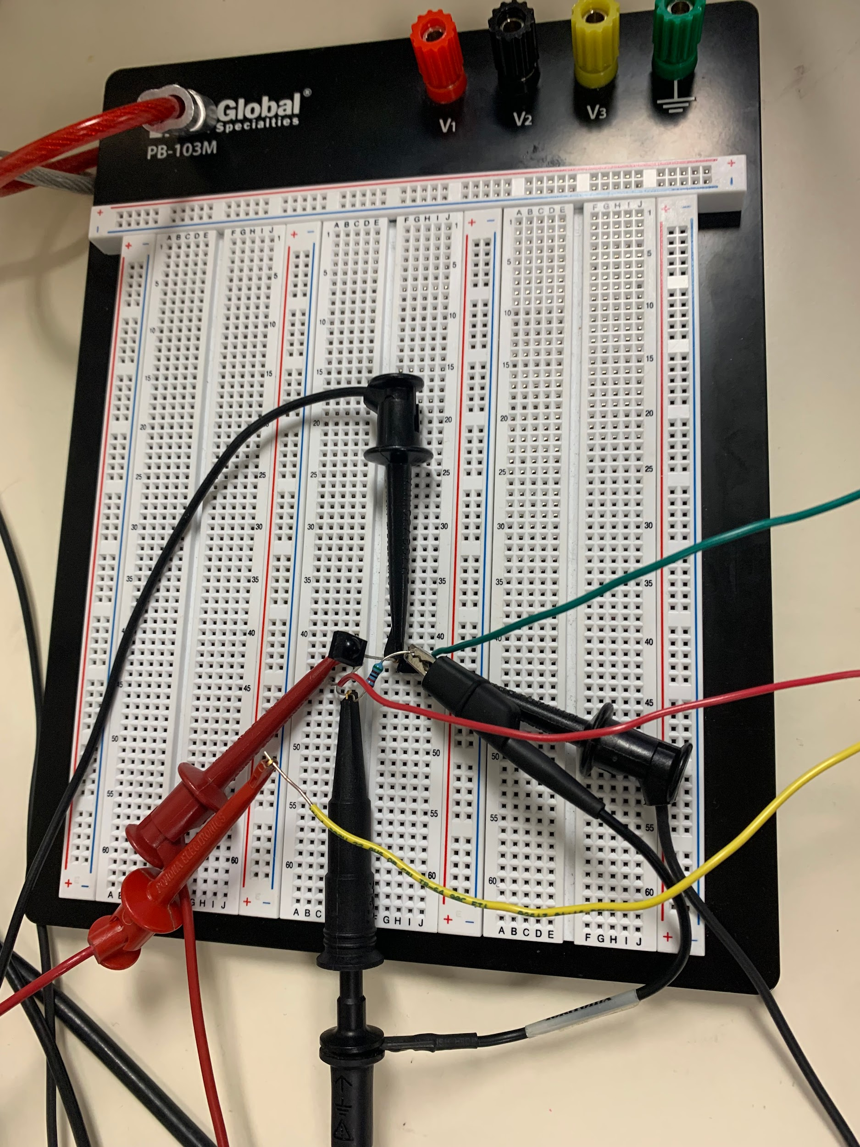

**Output from the Monitor and board:**

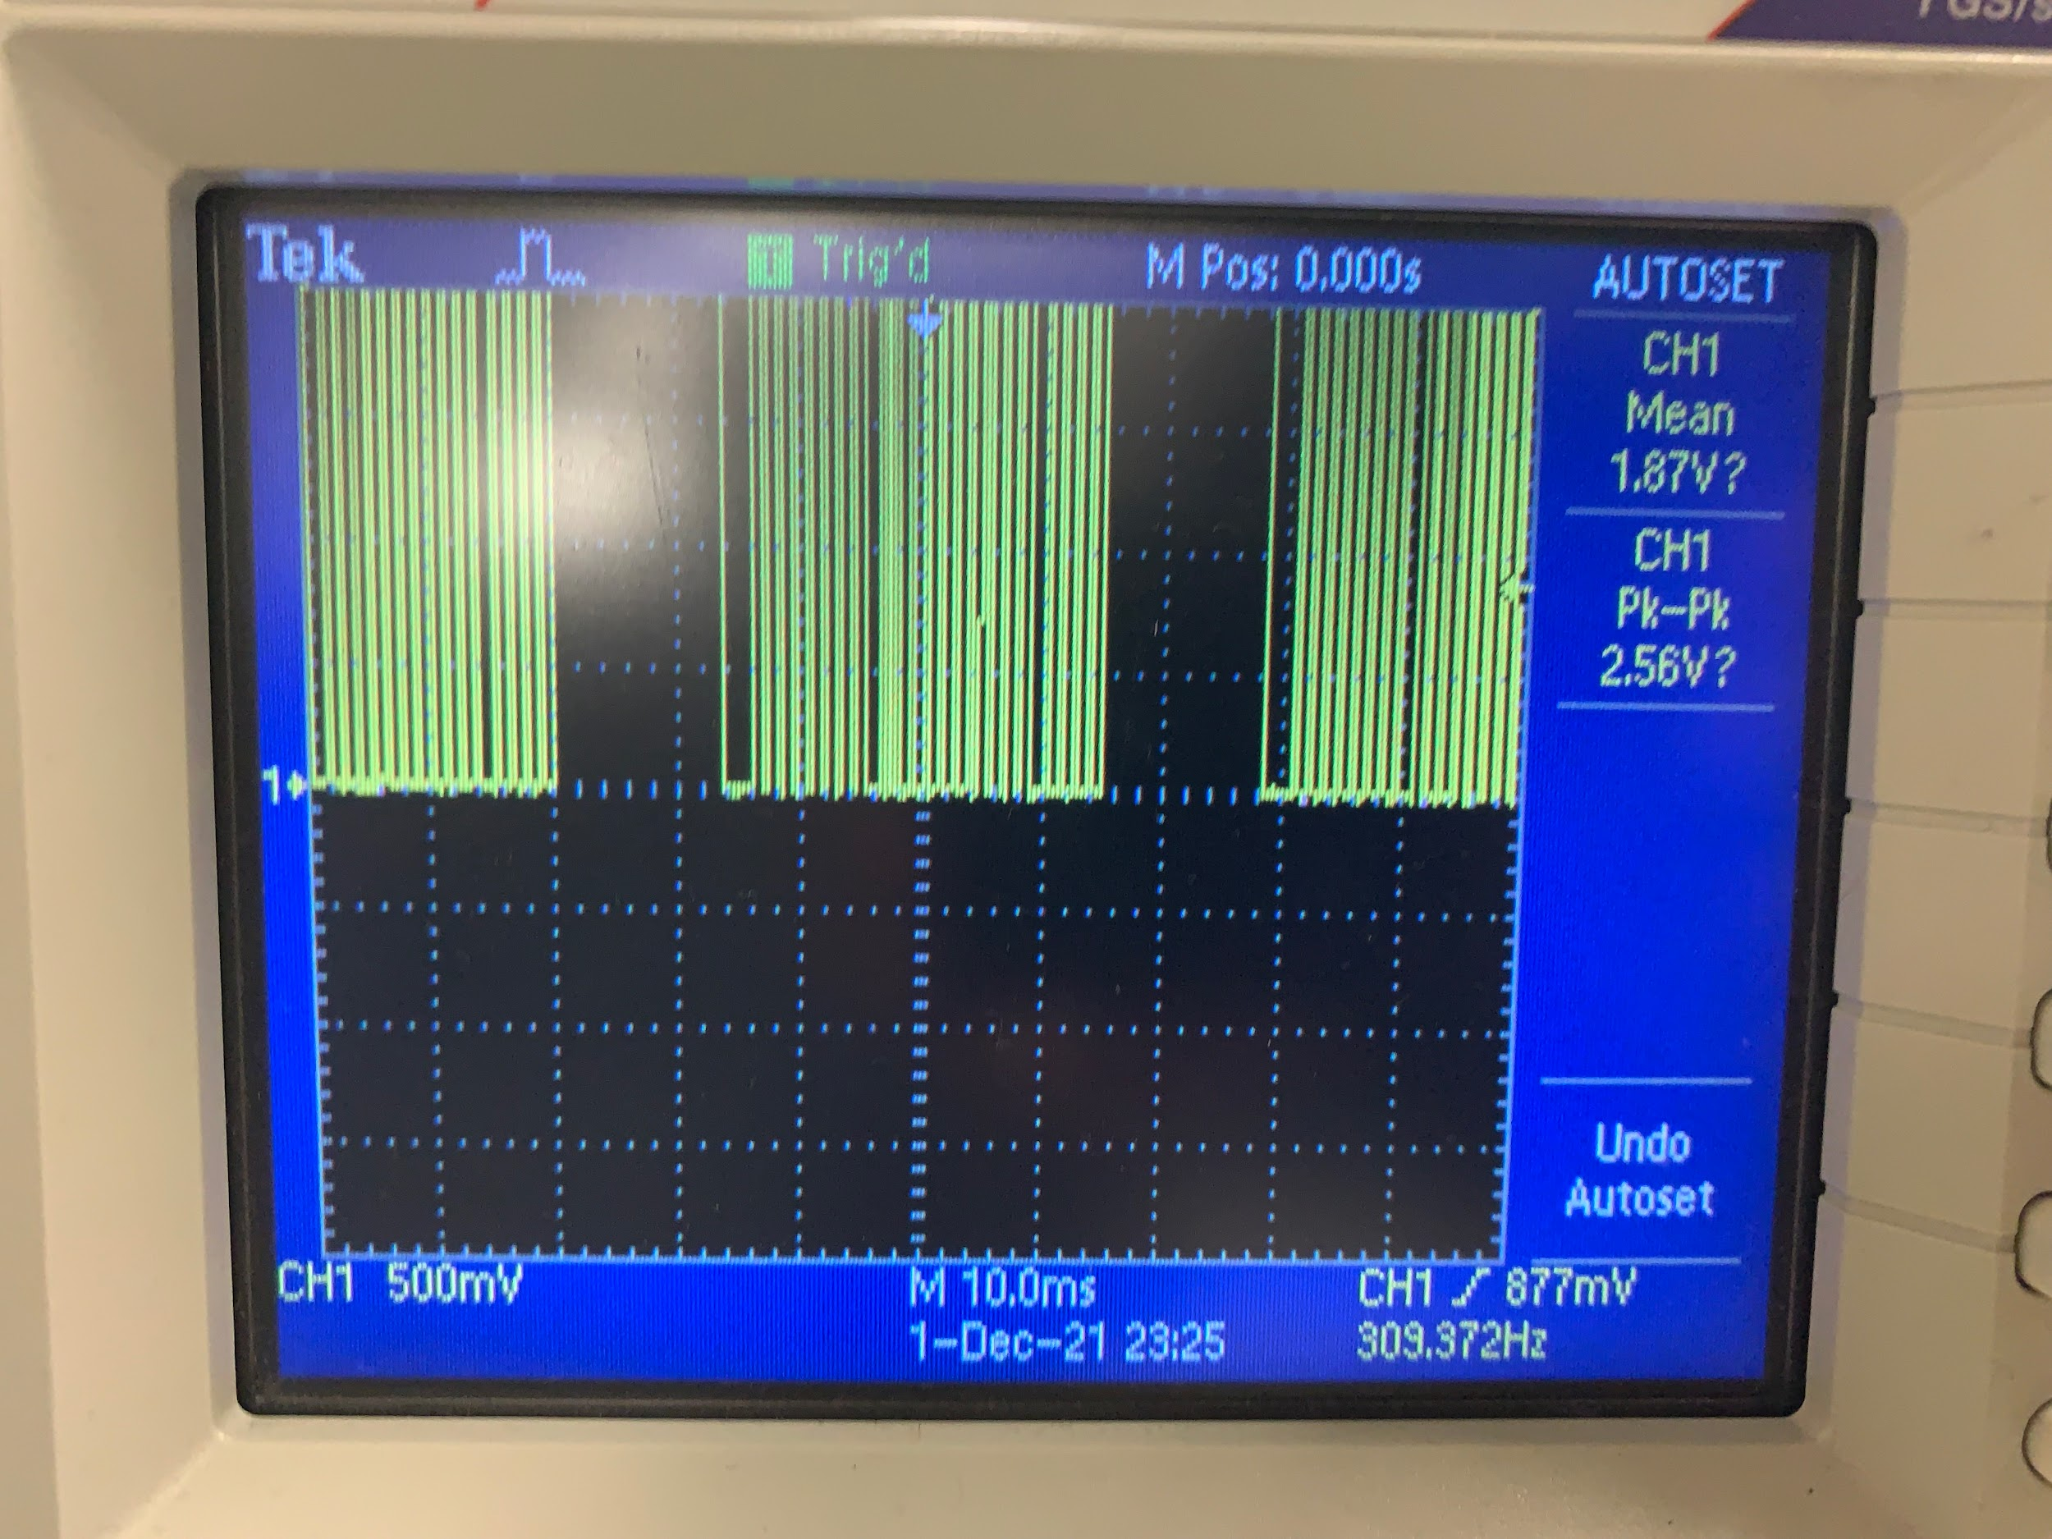

**Analysis:**

For this lab, we combined the work from multiple previous labs to build a calculator that takes the input from an IR remote to display it on a 7-segment display. To begin, we created a 4-bit adder using the full adder code design from lab 2 by cascading the design to connect each full adder’s carry output to the following one. To create a 4-bit adder, we naturally needed four full adders. The result bit each from each of the full adders will display the 4-bits of the design. The carry-in for the first full adder is zero because no lower-digit addition occurs. The 4-bit adder takes two inputs inA, inB, and produces an output, sum. After we wrote the module for the 4-bit adder, we wrote the simulation and ran it to find the adder code worked properly. We connected the carry in to zero and left the carry out open by not connecting anything, we put 1’b0 in place of the pin. Then, we completed filling the missing parts for lab5op by inserting the modules from previous labs. We substituted the lab with the correct variables used in lab5top.v. We did not need to run a simulation because of the sheer amount of variables involved.

**Conclusion:**

This lab 5 made for a combination of all labs we have through the rest of the quarter that we have worked on to create a systematic calculator on Bayss 3 board. It was the device that we are using a lot in our life. It shows how to make a calculator work in the real world, solve problems, and make a new thing. We are learning the fundamentals that will be used in Electrical engineering at UCSD. We discovered some code technical issues throughout the lab and promptly understood how to write stimulation test data. With the helped of code and data we get from the TA, we can code according to the requirement for the lab. We can write the stimulation for the 4 Bit adder and IR receiver itself. We can implement and learn how to use Verilog tools and code to do projects outside the course. We can understand the assignment pin for the board and connect the circuit to run the test we need it to be. The course was valuable for an engineering student. It would be beneficial for all students.